A335-Asia-Gandhara-Buddha in alcove-Schist-Kushan Period-4th Century CE

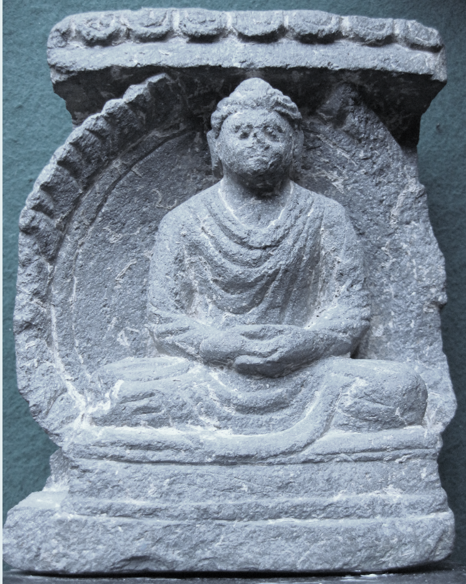

Fig. 1. Gandhara-Buddha in alcove-Schist-Kushan Period-4th Century CE

**Case no.: 3**

**Accession Number: A1126**

**Formal Label:** Gandhara- Buddha in alcove-Schist-Kushan Period-4th Century CE

**Display Description:**

This example of a small carving of a Buddha in an alcove is meant to represent a larger image carved in life-size, possibly at Taxila. The Kushan Period art of Gandhara in Peshawar Valley flourished by commemorating the Jatakas during the reign of king Kanishka the Great (128–151 AD/CE), when the cities of Taxila (Takṣaśilā) at Sirsukh and the capital at Peshawar were built. Kanishka as a patron of Buddhism helped diffuse the religion to Central Asia and the Far East across Bactria and Sogdiana (now Xinxiang Province), where his empire intersected with the Han Empire of China. This attracted Chinese pilgrims to worship at Buddhist monuments along the Silk Road. Mahayana Buddhism represented the Buddha in human form and many new sculptures of the Buddha were carved and new stupas and painted and sculptured caves were built while others were enlarged.

In fact, enormous statues of the Buddha were erected and carved into hillsides such as the ones carved from a sandstone cliff at Bamiyan in 507 CE and 554 CE in the Hazarajat region of central Afghanistan, 230 km NW of Kabul at an elevation of 2,500 m. representing classic Gandharan style.

**LC Classification**: [NB992.2.K36](http://josiah.brown.edu/search~S7?/c2-SIZE+NB992.2.K36+B87+1978/cnb++992.2+k36+b87+1978/-3%2C-1%2C0%2CE/frameset&FF=cnb++992.2+k36+b87+1978&1%2C1%2C)

**Date or Time Horizon:** Kushan Period-4th Century

**Geographical Area:** Taxila, Gandhara (modern location: Rawalpindi District, Punjab, Pakistan)

|  |  |
| --- | --- |
|  |  |

**Map, GPS coordinates:** [33°44′45″N 72°47′15″E](https://tools.wmflabs.org/geohack/geohack.php?pagename=Taxila&params=33_44_45_N_72_47_15_E_region:PK_type:landmark)

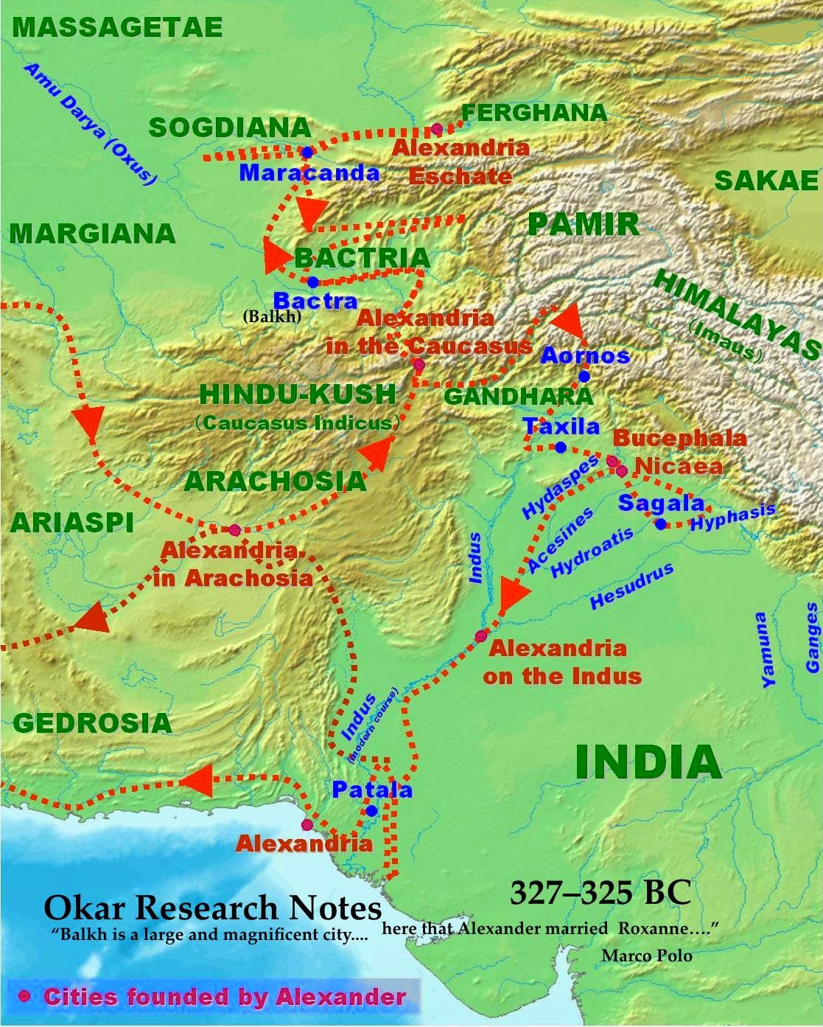

Fig. 2. Map of Gandhara and area where Alexander founded cities and where Buddhist statues have been found from http://2.bp.blogspot.com/-ykxrKlxxjkg/U5rg7JPM_RI/AAAAAAAAC9o/CvRbz8pUfbc/s1600/AlexanderConquestsInIndia.jpg

**Cultural Affiliation:** Gandhara

**Medium:** schist.

**Dimensions:** H 121.42 mm; 4.80 in.

**Weight: 1560 gm; 3.7 oz.**

**Condition: original**

**Provenance:** unknown

**Discussion:**

Taxila (Greek for Takshashila,”Rock of Taksha”) in Indian and Greco-Roman accounts and by Chinese Buddhist pilgrims, Faxian and Xuanzang as the prosperous and well-governed capital of the kingdom of Gandhara and as a great center of learning. In 326 BCE, Ambhi (Omphis), the ruler of Taxila, surrendered the city to Alexander and placed his resources at Alexander’s disposal.

**References:**

Allchin, Bridget and Raymond Allchin. 1988. *The rise of civilization in India and Pakistan.* Cambridge: Cambridge University Press.

Allchin, F. Raymond. 1993. "The Urban Position of Taxila and Its Place in Northwest India-Pakistan," *Studies in the History of Art*, 31: 69–81.

Cunningham, Alexander. 1871. *The Ancient Geography of India: The Buddhist Period, Including the Campaigns of Alexander, and the Travels of Hwen-Thsang*. Cambridge: Cambridge University Press.

Marshall, John. 1960. *A guide to Taxila* (4th ed.). Cambridge: Cambridge University Press.

Marshall, John. 1951. *Taxila: an illustrated account of archaeological excavations carried out at Taxila under the orders of the Government of India between the years 1913 and 1914*. 3 v. Delhi: Barnasidass.